M2C Application in Eclipse

How to set up the application and how it's structured

This assumes that the necessary android JDK and the phonegap library are downloaded and installed. I might make a guide for that later if I have time and energy.

Creating project
1. Start Eclipse and create a new android project
File -> New -> Project -> Android App.
2. Name the project and click next until the end of the wizard
I named the project M2C App. The four choises at bottom are for what version of android you want to create the application for. Android 2.2 Frodo seem to be a popular choise on various forums the reason is that the vast majority runs 2.2 or newer. Also The API for 2.2 contains most of the important calls you might need.
When you have named your project click next until the wizard disappears.

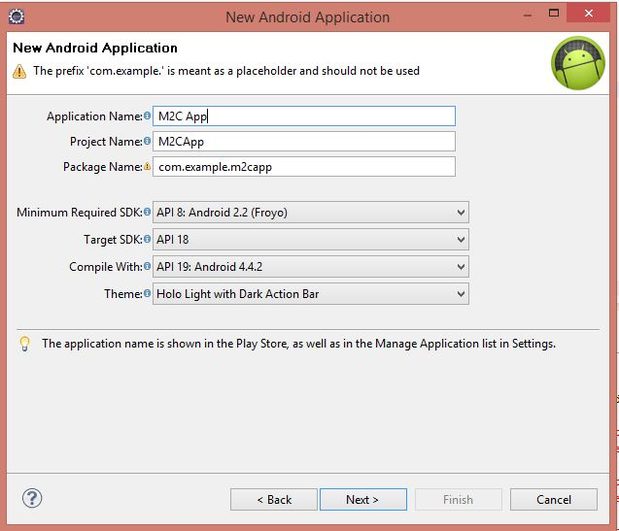

Inside eclipse in the Package explorer the wizard has autogenerated files and folders. IT should look like picture 2.
Most of the following is taken from: http://code.tutsplus.com/articles/introduction-to-android-development--mobile-7
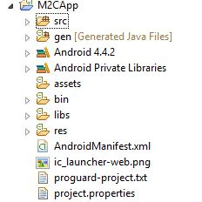
"src folder contains all of your custom source code, grouped into packages. Packages are simply there to help categorize your source code into logical (and manageable) groups. "

"gen folder is where code is generated for all the resources defined in your res folder. This is how you can access layouts and controls defined within your code."

Android 4.4.2 contains your android.jar file or something similar. It's where all your android specific classes are bundled together in to one file. It should be refering to where you installed the android-sdk in the "platforms" folder.

"assets folder is a place to store miscellaneous files you need to access in your code as raw data. All files in the res folder have methods to load the specific types, whereas the only way to load something from assets is to programmatically open it as a file."

bin contains the binaries and so far I haven't had any reason to go there.

Libs is your library folder. The Android ANT looks in the libs folder. If you want to know more about ant search for Android ANT and Apache ANT. [If I learn more about ANT, libs etc I will add it here]

res is your resouce folder. It contains drawable folders that contains different image resolutions so it's possible to support different screen resolutions.

ldpi ~ 120 dots per inch
mdpi ~ 160
hdpi ~ 240
xhdpi ~ 320
xxhdpi ~ 480 (Not defined in the official documentation)

To access the resources android uses a class called "R" that is located in your gen-folder.

Adding phonegap
For phonegap to work we add a "www" directory to assets where we store the view, javascript and css.
Go to where you downloaded PhoneGap
1. phonegap-x.x.x\lib\android\framework\ and copy "assets" to your project.
The folder contains cordova which might be called phonegap in same cases. This is the javascript you will use in your project. The index is the view and starting point of the project.
2. Copy cordova-xxx.jar to your libs folder.
For me it was located in the framework folder
3. Go to res/ and copy the xml folder to your projects res/ folder.
4. Open eclipse and go to libs/ and add cordova to your Build Path.
[Right click] -> "Build Path" -> "Add to Build Path"
5. If you have access to this projects files. Add the www folder to your project.

In src you will find MainActivity.java if you left it by default in the previous wizard. This has to be updated so it links to your index file, or what ever you named your starting point, and also extend the phonegap extention.

1. Open MainActivity
2. import org.apache.cordova.DroidGap;
3. Change onCreate from private to public.
4. Make your class extend DroidGap instead of Activity
5. Replace: setContentView() with: super.loadUrl("file:///android_asset/www/index.html");
android_asset maps to your assets folder.

Now we have to edit the configuration files to set the applications permissions. Open AndroidManifest.xml located in your root folder with a text editor of your choise. You can use eclipse by right clicking the file and choose "open with" and "Text Editor". There is a reference picture after the steps.

1. Open AndroidManifest.xml
2. Add between </application> and </manifest>

<supports-screens
android:largeScreens="true"
android:normalScreens="true"
android:smallScreens="true"
android:resizeable="true"
android:anyDensity="true"
/>

<uses-permission android:name="android.permission.CAMERA" />
<uses-permission android:name="android.permission.VIBRATE" />
<uses-permission android:name="android.permission.ACCESS_COARSE_LOCATION" />
<uses-permission android:name="android.permission.ACCESS_FINE_LOCATION" />
<uses-permission android:name="android.permission.ACCESS_LOCATION_EXTRA_COMMANDS" />
<uses-permission android:name="android.permission.READ_PHONE_STATE" />
<uses-permission android:name="android.permission.INTERNET" />
<uses-permission android:name="android.permission.RECEIVE_SMS" />
<uses-permission android:name="android.permission.RECORD_AUDIO" />
<uses-permission android:name="android.permission.MODIFY_AUDIO_SETTINGS" />
<uses-permission android:name="android.permission.READ_CONTACTS" />
<uses-permission android:name="android.permission.WRITE_CONTACTS" />
<uses-permission android:name="android.permission.WRITE_EXTERNAL_STORAGE" />
<uses-permission android:name="android.permission.ACCESS_NETWORK_STATE" />
<uses-permission android:name="android.permission.GET_ACCOUNTS" />
<uses-permission android:name="android.permission.BROADCAST_STICKY" />

When you know what to access, remove the permissions you don't need. This directly translates to the permission screen that pops up when the user install the app.

3. Find the <activity> node and add: android:configChanges="orientation|keyboardHidden"
should look like this:
<activity
android:name="com.example.m2capp.MainActivity"
android:label="@string/app_name"
android:configChanges="orientation|keyboardHidden" >

From developer.android.com: configChanges "lists configuration changes that the activity will handle itself. When a configuration change occurs at runtime, the activity is shut down and restarted by default, but declaring a configuration with this attribute will prevent the activity from being restarted. Instead, the activity remains running and itsonConfigurationChanged() method is called."
This means that the activity will handle what happens if the screen rotates or the keyboard accessability changes.

Since we are using phonegap we will create an activity for the DroidGap class.
4. Create a sibling node to the already existing activity node:
<activity
android:name="org.apache.cordova.DroidGap" android:label="@string/app_name"
android:configChanges="orientation|keyboardHidden">
<intent-filter>
</intent-filter>
</activity>

The empty intent-filter node decides on what kind of intents the parent node, in this case the application, can respond to. According to developer.android.com, "an Intent is a messaging object you can use to request an action from another app component".

Your AndroidManifest shoud look something like this:

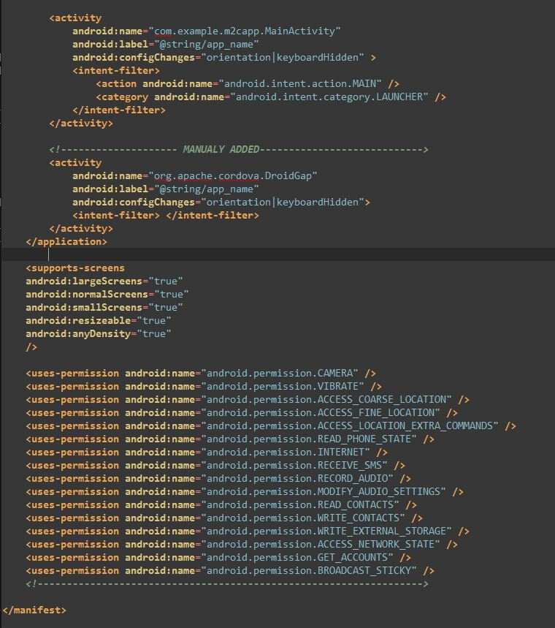
It should now be ready to launch.

The application can now be run on android and if you want to make it run on another operatingsystem you have to do a similar configuraion. To avoid this phonegap has a cloud based way of compiling your application.

